Protective Case for use with the
Arrow® VPS G4™ Interface
Setup Instructions

The enclosed protective case is used to mount the
Arrow® VPS G4™ Interface onto a GCX, or similar type, cart. These instructions describe how to insert the Interface into the case and then mount the assembly onto a 75 mm x 75 mm VESA-compatible mounting bracket (not included).

Please refer to the Arrow VPS G4 Device Operator’s Manual for complete instructions on using the Arrow VPS G4 Device.

List of Items Provided:
Four (4) Screws – Screw, pan head Phillips, M4x16mm SST
Four (4) Nuts – Hex Nut, Locking, M4 x 0.7mm Thread
One (1) Tablet Case – Kensington Enclosure for Android Tablet

List of Items Needed But Not Provided:
Wrench – M4 or 9/32”
Phillips Head Screwdriver
Android Tablet – Provided with VPS G4 Device
VESA plate – Provided with GCX Cart

Attaching Case to the VESA Mounting Bracket
- Slide out tab on rear of the Case (Figure 1).
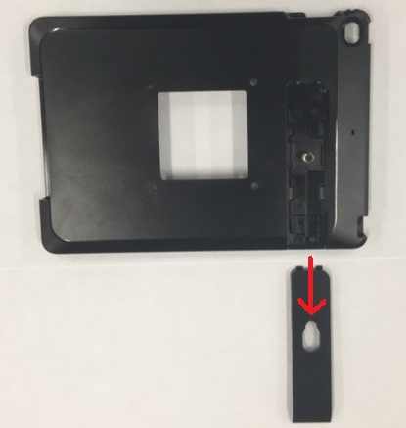
Figure 1: Slide the Tab Away From Case
- Pull apart the top and bottom sections of the Case to separate them (Figure 2).
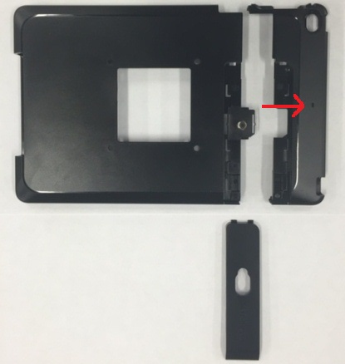
Figure 2: Separate the Case Pieces

- Align the four holes on large section of Interface Case with the four inner holes on the 75 mm x 75 mm VESA mounting bracket, ensuring the USB cable port is on the right side.

- Insert the four screws (provided) through the mounting bracket and into the case (Figure 3).
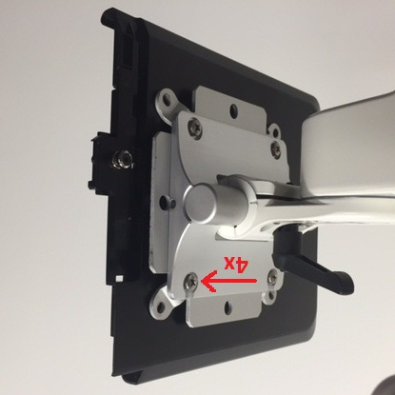
Figure 3: Insert the Four Screws
- Using a wrench, attach and tighten the four nuts (provided) to the screws on the inside of the Case (Figure 4).
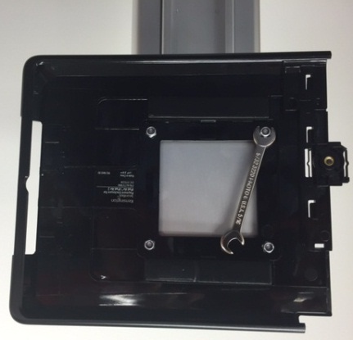
Figure 4: Attach Nuts to the Four Screws
Do NOT overtighten the nuts as this can result in a cracked case. They should be tightened just to the point of there being no gap between the nut and the case.

Assembling Interface and Case
- Slide the Interface into the Case (Figure 5).
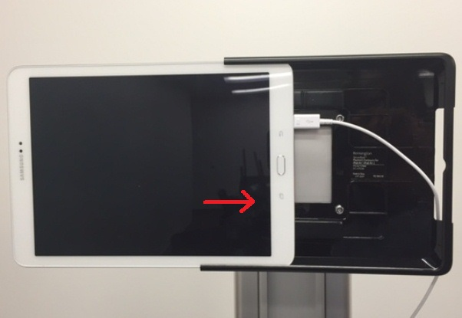
Figure 5: Slide Interface into Case

- Replace the smaller section of the Case and slide the tab firmly into place – it should “click” when it is in place (Figures 6 and 7).
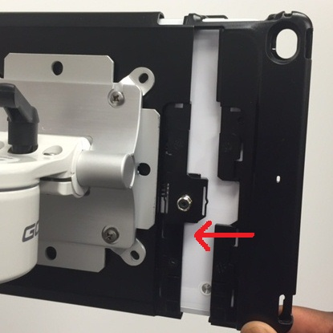
Figure 6: Replace the Smaller Section
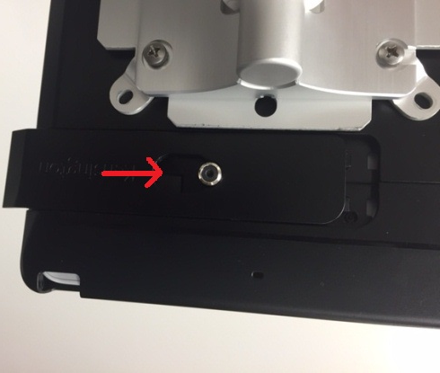
Figure 7: Slide Tab Firmly Into Place
- The Interface is now secure and ready to be used.

NOTE: For additional security, a compatible locking device can be purchased separately, either from Teleflex or via an alternate online vendor:
ClickSafe® Keyed Laptop Lock, part # K64637WW.

Teleflex, the Teleflex logo, Arrow, and VPS G4 are trademarks or registered trademarks of Teleflex Incorporated or its affiliates, in the U.S. and/or other countries.
© 2016 Teleflex Incorporated. All rights reserved.

ClickSafe is a trademark or registered trademark of ACCO Brands Corporation and its Subsidiaries.

Distributed by:
Teleflex Medical
IDA Business and Technology Park
Dublin Road, Athlone
Co. Westmeath, Ireland

Teleflex US Customer Service (product and accessory orders):
Tel: +1.866.246.6990
Fax: +1.866.804.9881
E-Mail: cs@teleflex.com

Teleflex US VPS Technical Support:
Tel: +1.877.236.6869
Email: vpstechsupport@teleflex.com
Web site: www.arrowvascular.com/vps
www.teleflex.com

